
SEND Information Report for Monksmoor Park CE Primary School
At Monksmoor Park, we are deeply committed to providing an inclusive education that celebrates the unique qualities of every child. Our approach, rooted in the principles of The Inclusive Classroom (Sobel and Alston) and the work of Anita Devi on SEND leadership and inclusion, ensures all children are supported to thrive in a nurturing environment. We tailor support to match individual needs, guided by the SEND Code of Practice (2015) and The Church of England Vision for Education, which emphasises wisdom, hope, community, and dignity.
This report outlines how we meet the needs of pupils with SEND, ensuring every child receives the support they need to achieve their potential.

1. Contact Information
SEND Co-ordinator (SENDCo): Pip Bates
Contact email: pbates@monksmoorceprimary.co.uk
Contact phone number: 01327 493112
SEND and Inclusion Governor: Marion Strange
For further information, parents and carers are encouraged to contact the SENCo directly.

2. SEND in our school
In accordance with the SEND code of Practice, a pupil is identified as having SEND if they have a learning difficulty or disability that requires special educational provision to be made for them. At Monksmoor Park we support pupils with a wide range of SEND, including:
Communication and interaction: including speech, language and communication needs, such as Autism Spectrum Disorder (ASD).
Cognition and Learning: including learning difficulties such as dyslexia, dyspraxia, and general developmental delay.
Social, Emotional and Mental Health: including anxiety, ADHD, emotional regulation challenges.
Sensory and/or Physical Needs: including visual and hearing impairments, as well as physical disabilities and sensory processing difficulties.
Through our inclusive and nurture-based approach, we ensure that all children are fully integrated into the school community, regardless of their needs, and that they receive the support they need to thrive and succeed. Using the Provision for All strategy, we ensure that every child, not just those identified as SEND, benefit from inclusive practices.

3. Identification of SEND
The identification of SEND at Monksmoor Park is an ongoing and collaborative process, based on the following methods:
Early Identification: Teachers use regular assessments and observations to identify pupils who may not be making expected progress or who may need additional support beyond quality first teaching.
Collaboration with parents/carers: Parents/carers are key partners in the identification of SEND and we encourage open dialogue in order to share concerns or observations.
Specialist Assessments: Where necessary, we work with external agencies (such as speech and language therapists, educational psychologists, and occupational therapists) to carry out detailed assessments and to provide advice to guide support.
Graduated Response: We follow a graduated approach, based on the Assess, Plan, Do, Review cycle, ensuring that any support is tailored to the child’s needs and that progress is carefully monitored.
Provision Map: We utilise the Provision Map by Edukey to track and monitor all interventions and support accessed by pupils with SEND. This software allows us to create detailed records of each child’s specific needs and the provisions in place for them; it ensures transparency, and allows all staff to have access to up-to-date information on each child’s provision and progress.

4. Assessment and progress
It is important that we regularly monitor and review the progress of all pupils with SEND to confirm the provision in place is appropriate for each individual. We do this through:
Individual Learning Plans (ILPs): ILPs outline the specific targets and strategies for each pupil with SEND. These are tracked using the Provision Map and are reviewed termly, with input from the pupil, their parents/carers, and the staff with whom they work.
Ongoing Formative Assessment: Teachers assess pupils’ learning continuously to monitor progress and to adjust support where appropriate.
Annual Reviews: For pupils with Educational Health Care Plans (EHCPs), we conduct formal annual reviews to assess their progress, update targets and provide a comprehensive overview of the child’s needs. These are held in accordance with the guidance from the local authority, who are invited to attend the meetings along with any other external specialists in a multi-agency approach.
Provision Map: By using the Provision Map tool, we can review and adjust the interventions and support accessed by each child dynamically in order that they remain effective in meeting the specific needs of each pupil.

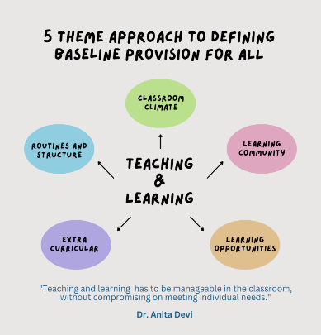
5. Adaptive teaching and the Classroom
Our teaching is fully inclusive, affording every child a broad and balanced curriculum and ensuring access for all pupils. We achieve this through:
Quality First Teaching: All teachers differentiate lessons and resources to meet the needs of all children in the classroom, including those with SEND. This might involve breaking down tasks, using visual representations, or providing extra scaffolds or support.
Specialist Equipment and Resources: Where needed, we provide specialist equipment such as, sensory tools, communication aids or adapted learning materials.
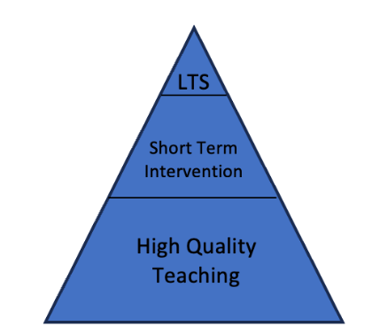
Additional Adult Support: Teaching Assistants and Specialist staff provide targeted support both in and out of the classroom, ensuring all pupils receive the help they need to achieve their potential.
Provision for All: The Provision for All strategy ensures that every classroom incorporates the inclusive teaching practices that benefit all students, not just those with identified SEND. This inclusive ethos promotes Universal Design for Learning (UDL) and makes learning accessible for every pupil.

6. Broader School Life
We believe in providing every pupil with equal opportunities to participate in all aspects of school life. This includes:
Clubs and Activities: Pupils with SEND are encouraged to participate in all after-school clubs, sports and trips. Where needed, reasonable adjustments are made to ensure accessibility.
Whole School Events: We ensure that pupils with SEND are fully involved in all whole school events, such as assemblies, performances and celebrations by providing tailored support and adjustments where necessary.
Social Integration: Rooted in a culture of acceptance and support, we strive to foster positive relationships between all pupils through buddy schemes and peer mentoring.
Provision Map: We use provision map to track the participation of our SEND pupils in extracurricular activities and social integration in order that no child is excluded from the enrichment opportunities these provide.

7. Social and Emotional Development

Supporting the emotional wellbeing of our pupils is central to our inclusive approach, we know that a feeling of belonging and a sense of connection is crucial for children’s sense of self. With this in mind, we provide:
Pastoral support: Our pastoral team offers 1:1 sessions, group interventions and social skills groups to help pupils with SEND to develop confidence and social understanding.
Emotional Literacy Support: We run Emotional Literacy Support programs with our trained Emotional Literacy Support Assistant. These targeted sessions are aimed at helping pupils to manage anxieties, improve self-esteem and emotional resilience.
Positive Handling Plans: For pupils with Social, Emotional and Mental Health difficulties, we develop personalised behaviour plans in collaboration with families and external agencies.
Mental Health Support Team: Monksmoor Park works in partnership with Daventry’s MHST to provide early intervention for children with mild/moderate mental health difficulties. Referrals to the service can be made via the SENCO.

8. Working with Parents/Carers
We place high value on building strong partnerships with parents and carers: collaboration is key to creating successful outcomes for children and young people with SEND, as outlined in Provision for All. We maintain regular communication through:
Parent meetings: Termly meetings are held to review ILPs, providing opportunities to review progress and set new targets. During these, we welcome parents/carers’ insights and work collaboratively to support each child to flourish and grow.
Open Communication: Teachers and SENCO are available for information discussions, and parents are encouraged to communicate any concerns promptly.
Workshops and Support Groups: We offer parent workshops on supporting children with SEND at home and facilitate SEND support groups to foster a community amongst parents.
Provision Map: The Provision Map system enables parents to stay informed about the support their child is receiving and to track their progress through regular updates.

9. Staff Expertise
Our staff are committed to continuous professional develop so that we can ensure the highest quality of SEND provision. This training includes:
In house training: Regular CPD sessions cover strategies and support for specific SEND needs, including ASD, dyslexia, anxiety and Speech and Language needs.
Specialist Training: Staff work with external specialists to deepen their understanding of SEND, guided by the principles of The Inclusive Classroom and the expertise of Anita Devi (the Provision for All framework). We also benefit from support by specialist SEN teams in our local authority.
Dedicated SENDCo: Our SENDCo is a fully trained and experienced professional, responsible for coordinating SEND provision across the school.

10. Funding and Resources
We understand the importance of transparency and accountability in how resources are allocated to meet the diverse needs of pupils with SEND.
By clearly outlining how funding is used, we can demonstrate our commitment to supporting every child effectively and build trust with parents, carers, and other stakeholders. Transparency: Detailing how funding is allocated provides clarity for parents and carers, helping them understand the scope and limits of the support their child may receive.
Accountability: By explaining decisions about spending, we can ensure we are held accountable to stakeholders, including the local authority and the wider school community.
Targeted Support: Clearly defined allocations (e.g., for EHCPs or Pupil Premium) ensure that funding is used effectively to address the specific needs of pupils, such as providing specialist equipment, targeted interventions, or additional staffing.
Collaborative Decision-Making: Outlining the role of the SENCo, leadership team, and parents in prioritising resource allocation ensures that funding decisions are collaborative and consider diverse perspectives.
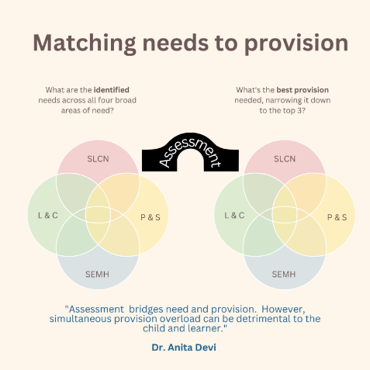
Equity and Inclusion: Explaining the allocation of funds for disadvantaged SEND pupils through Pupil Premium ensures equity and highlights the school’s commitment to inclusive education.
Adaptability to Evolving Needs: Regular review and flexibility in resource allocation demonstrate the school’s responsiveness to changing pupil needs, ensuring that support remains relevant and impactful.
Access to Expertise: Funding for external agencies ensures that pupils with complex needs receive expert support, which may not be available within the school.
Further detailed information of any of the above is available is requested.

11. Effectiveness of SEND Support
Maintaining the effectiveness of SEND support is essential to ensure that every pupil can achieve their full potential, fostering not only academic progress but also social, emotional, and personal growth in a nurturing and inclusive environment. As Monksmoor Park we use several ways to ensure our children benefit from effective support:
- Monitoring Pupil Progress
- Regular assessments (formative and summative) are conducted to track the progress of pupils with SEND.
- Outcomes of interventions are reviewed termly through the Assess, Plan, Do, Review cycle.
- Regular consultations with parents, carers, and pupils help evaluate whether the support meets individual needs.
- Staff feedback during training sessions and team meetings helps refine provision.
- Data Analysis
- Progress data of SEND pupils is compared to peers and national benchmarks.
- Attendance, behavior, and social integration data are analyzed to assess well-being and inclusion.
- Governance Oversight from SEND and Inclusion Trustee
- Support from Trust SEND and Inclusion lead, including - quality assurance, monitoring and impact evaluations for the Trust Board
- Key findings are reported to the LGB and Trustees and included in the school’s annual SEND review.

12. External Agencies
In line with Provision for All, we work collaboratively with a range of external specialists to gain expert advice and to provide additional support where needed. These agencies may include:
- Speech and Language Therapists
- Educational Psychologists
- Child and Adolescent Mental Health Services (CAMHS)
- Mental Health Support Services
- Inclusion and Intervention Support Team (IIST)
- Local Authority Offer: including the School Support Partnership (SSP) and the County Area SENCOs and Teen health team.

13. Local Offer
Our SEND provision aligns with West Northamptonshire’s Local Offer, which provides information on services and support available for children with SEND. For more information, visit the West Northamptonshire Local Offer website.

14. Transition Support
We know that transitions can be a difficult time for all children, but especially those with SEND. We are therefore committed to supporting smooth transitions wherever possible, whether these be within our school or to new settings.
When moving between classes, pupils receive tailored transition support to prepare them for their new environment and adults.
When moving to a new school or setting, we liaise closely with the new school, facilitating extended transitions where possible, especially in the transition to secondary school.

15. Complaints Procedure
We strive to resolve concerns collaboratively and informally wherever possible. Parents wishing to raise formal concerns about SEND provision should follow the school’s Complaints Policy, available on the school website or by request.

16. Review of the Report
This SEND Information Report is reviewed annually to ensure it reflects current practices and statutory requirements. The next review is scheduled for September 2026

